

*Agent-Based Software Engineering*  
Assignment 02

Name : Muhammad Shamoil  
Section : BSSE – V – A  
Date: 25th October 2025  
Submitted To : Sir Anwaar

Contents

1. Introduction 2

2. Using GAIA for Identifying Roles, Interactions, and Structure 2

2.1 Roles Identification 2

2.2 Interaction Model 3

2.3 Organizational Structure 4

3. GAIA Design Models 4

3.1 Role Model Diagram 4

3.2 Interaction (Protocol) Diagram 5

3.3 Service Model Diagram 5

4. Summary 6

5. Conclusion 6

6.References 6

***GAIA Methodology for Smart Healthcare Monitoring System***

## 1. Introduction

GAIA is an agent-oriented software engineering methodology used for analyzing and designing multi-agent systems (MAS). It focuses on identifying roles, interactions, and organizational structures that exist in a system before defining agents.  
  
In a Smart Healthcare Monitoring System (SHMS), GAIA helps in modeling how different entities like patients, doctors, sensors, and servers interact as agents within a well-defined organization.

## 2. Using GAIA for Identifying Roles, Interactions, and Structure

### 2.1 Roles Identification

In GAIA, a role defines what a participant (agent) does in the system. Each role is described using four attributes:

1. **Responsibilities :** including the main tasks and goals the agent is supposed to be performing
2. **Permissions :** including the data and the resources that are accessible for the agent to use
3. **Activities :** Including the actions that the agent can perform by itself without relying on other agents
4. **Protocols**: The rules for the agents by which the agent will communicate with other agents , an agent must abide by the protocols while communicating.

***Roles in Smart Healthcare Monitoring System***

|  |  |  |  |  |
| --- | --- | --- | --- | --- |
| Role | Responsibilities | Permissions | Activities | Protocols |
| Patient Role | Wear sensors, provide health data | Access personal medical data | Send readings periodically | Communicate with Monitoring Agent |
| Sensor Role | Collect vital signs (heart rate, BP, temperature) | Access patient sensor data | Measure and transmit data | Report to Patient and Monitoring Agents |
| Monitoring Agent Role | Analyze incoming data, detect anomalies | Access all patients’ data | Run health checks, trigger alerts | Communicate with Doctor and Alert Agents |
| Doctor Role | Review health reports, advise patients | Access patient reports | Diagnose, prescribe treatment | Interact with Monitoring and Patient Agents |
| Alert Role | Send emergency notifications | Access critical patient alerts | Generate alerts automatically | Notify Doctor and Emergency Services |
| Database Role | Store and retrieve records | Full access to historical data | Update, backup, query | Interact with Monitoring Agent |

### 2.2 Interaction Model

GAIA defines protocols between roles that describe how they communicate.  
Main Interactions in SHMS:  
1. Sensor → Monitoring Agent: Send periodic health data.  
2. Monitoring Agent → Doctor: Send reports or alerts.  
3. Doctor → Patient: Send diagnosis or advice.  
4. Monitoring Agent → Alert Agent: Trigger emergency messages.  
5. Monitoring Agent ↔ Database: Store and retrieve patient data.

### 2.3 Organizational Structure

The organizational structure defines how the roles are grouped and related.  
In this case:

* The Monitoring Agent acts as the central coordinator.
* Sensor Agents and Patient Agents are data sources.
* Doctor and Alert Agents are decision and response units.
* The Database Agent supports persistence and record management.

Structure Type: A centralized or hierarchical organization would be suitable to use in this condition because the monitoring agent controls the communication flow between other agents.

## 3. GAIA Design Models

After the analysis phase, the GAIA includes a design phase which includes performing and producing three main diagrams

### 3.1 Role Model Diagram

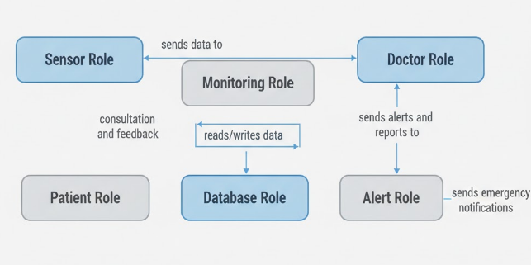

Explanation: The sensor data sends the data to the monitoring role or the monitoring agents that send the data to the doctor role and also updates and informs the database. The doctor can communicate directly with the patient. In case of emergencies, the monitoring role by using the doctor role alerts or activates the alert role. The monitoring role is supposed to stay out and monitor all of the things. So, it is not directly a part of it.

### 3.2 Interaction (Protocol) Diagram

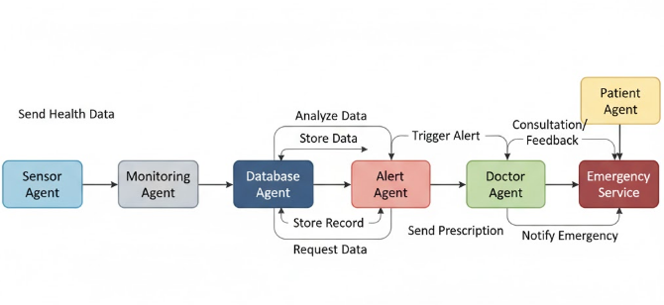Explanation: Data flows from Sensor to Monitoring Agent. The Monitoring Agent interacts with Database, Doctor, and Alert agents. The Alert Agent forwards critical messages to emergency services.

### 3.3 Service Model Diagram

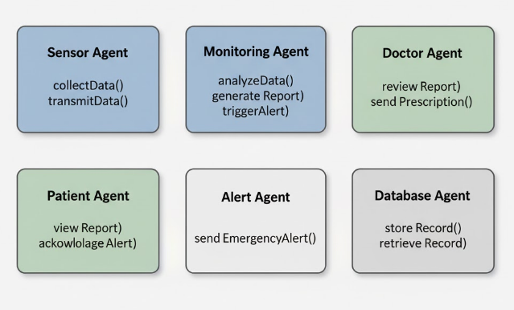

Services offered by specific agents have been clearly shown in the diagram as well as the table below.

|  |  |
| --- | --- |
| Agent | Services Offered |
| Sensor Agent | collectData(), transmitData() |
| Monitoring Agent | analyzeData(), generateReport(), triggerAlert() |
| Doctor Agent | reviewReport(), sendPrescription() |
| Patient Agent | viewReport(), acknowledgeAlert() |
| Alert Agent | sendEmergencyAlert() |
| Database Agent | storeRecord(), retrieveRecord() |

## 4. Summary

The GAIA methodology provides a well-structured and clearly defined method to design a smart healthcare monitoring system that is both properly structured and properly maintainable , it includes:

* Defining clear agent roles and their responsibilities.
* Establishing interaction protocols for communication.
* Creating an organizational structure that supports coordination and decision-making.

This results in a scalable, maintainable, and intelligent agent-based system capable of continuous health monitoring and timely medical response.

## 5. Conclusion

GAIA methodology helps transform complex healthcare systems into a set of coordinated agent roles that have properly defined protocols for intercommunication, with each responsible for a specific function or activity. Through this role-based and interaction-driven design, the Smart Healthcare Monitoring System can efficiently manage real-time data, automate alerts, and support medical professionals in providing better care using a properly maintained and sustainable system.

## 6.References

1. The core concept structure and concept of GAIA were referred to by the use of course slides.
2. The diagram was made by the use of modeling tools such as Lucid Draw and Draw.io.
3. ChatGPT and Perplexity, were used to better understand and solve the problem.